

High Level Design & Low Level Design

**INDEX**

1.Introduction

1.1 Purpose ---------------------------------------------------------------------------3

1.2 Intended Audience --------------------------------------------------------------3

2. Overall Description

2.1 Assumptions and Dependency-------------------------------------------------3

3. Design overview

3.1 Dataflow diagram----------------------------------------------------------------4

3.1 Overview of server client-------------------------------------------------------5

3.2 client side------------------------------------------------------------------------- 6

3.3 server side------------------------------------------------------------------------ 7

4. System Architecture

4.1 Functions------------------------------------------------------------------------- 9

4.2 Structure------------------------------------------------------------------------- 10

5. System Features and Requirements

5.1 Functionality--------------------------------------------------------------------- 11

5.2 System Requirements----------------------------------------------------------- 11

5.3 System Features----------------------------------------------------------------- 12

6. Tools Report

6.1 gprof ------------------------------------------------------------------------------ 13

6.2 CUnit ----------------------------------------------------------------------------- 14

7.Testing

7.1 Unit testing -----------------------------------------------------------------------15

8. Requirements Traceability Matrix

8.1 RTM-------------------------------------------------------------------------------16

### INTRODUCTION:

The introduction of the software requirement specification provides an overview of the entire software. The entire design with overview description purpose, scope, tools used and basic description. The aim of this document is to gather, analyze and give an in-depth insight into the complete Remote Calculate by defining the problem statement in detail. The detailed requirements of the Remote Calculate are provided in this document

**1.1 Purpose**: Remote Calculator relieves the user of the need to do mental operations and of the need not to rely on paper.

**1.2 Intended Audience: -** This document is intended to be read by Client.

1. **OVERALL DESCRIPTION:**

Connection established between server and client, Then the login is successful in admin mode of server side then only the further process will continue otherwise it will disconnected. After successful login, Server will takes the inputs from the client like number of arguments, operations so on. Server performs some operations like addition, subtraction, so on. After operation to be done then server sends the result to the client.

**2.1 Assumptions and Dependency:-**

* User should have the latest version of Ubuntu Linux installed.
* User should have minimum 4GB RAM.
* The service is available on a desktop or laptop

**3.DESIGN OVERVIEW**

3.1 Data flow diagram

Level 0

 Remote Calculator

Server Client

Username operations are Results are fetched

Password performed from the server

3.2 Flow chart for client server overview

Connection b/w Client & Server

Performs Operation in server

Exit or Disconnected

Send the Result to the client

Take the inputs from client

If login is successful

Inputs like no of arguments, no of operations etc

**YES**

**NO**

3.3 Flow chart for client side

Connection established With Server

Provide inputs

If login is successful

Exit or Disconnection

Result

Inputs like no of arguments, no of operations etc

**NO**

**YES**

3.4 Flow chart for server side

Connection with Client

Perform Operations

Exit or Disconnected

Send the Result to the client

Take Inputs from client

If login is successful

Inputs like no of arguments, no of operations etc

**YES**

**NO**

**4. SYSTEM ARCHITECTURE:**

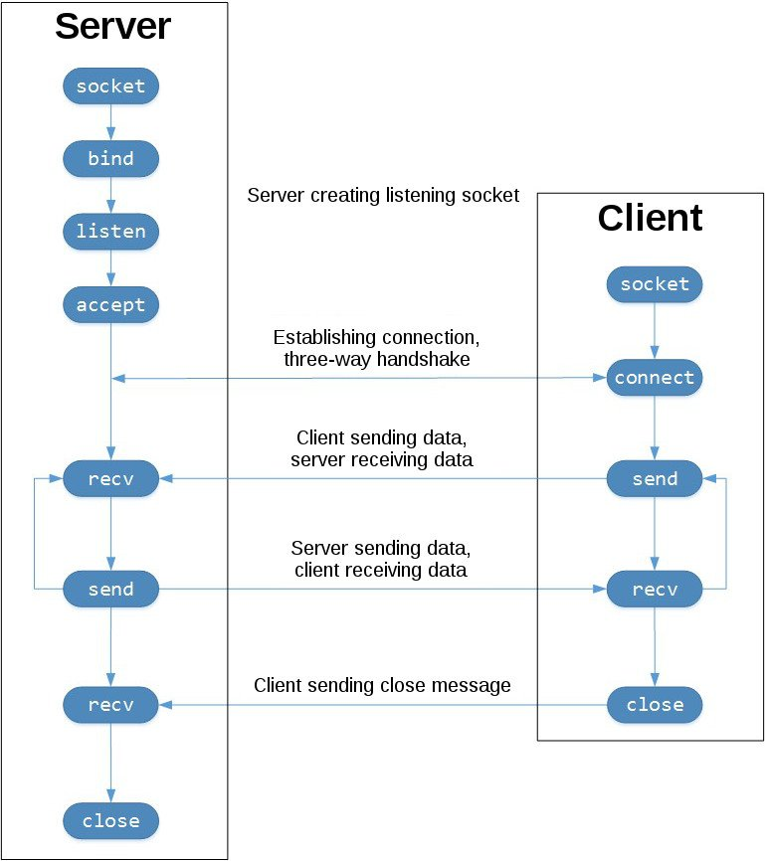

* 1. **FUNCTIONS:**
     1. **LOGIN functionality**

Admin Mode (Server side) which takes

* Login
* Username
* Password
* Register
* Exit

4.1.2 **CALCULATION**

Admin Mode (Server Side)

It is required to perform operations of addition, multiplication, subtraction, division with postfix, prefix and infix expression for calculation.

4.1.3 **ARGUMENTS**

Admin Mode (Server Side)

To add the number of arguments to be inputted followed by numbers using a colon, as a separator for the arguments as well as the operands.

4.1.4 **OPERATIONS**

Admin Mode (Server side)

It is to add the number of operations to be performed like for example: Addition, Subtraction, Multiplication, Division.

2.1.4.1 Input the operators using (;) semicolon as separators.

2.1.4.2 It is required to formulate the problem to be calculated to get the required output.

4.1.5 **RESULT**

User Mode (Client Side)

After the required calculation processed, It is required to fetch the results from the Server and provide it to the Client as per the request.

**4.2 STRUCTURE**

First enable the connection between server and the client.

**SERVER SIDE:** LOGIN

* USERNAME
* PASSWORD

REGISTER

EXIT

After successful login, Enter the arguments with operands.

Now select the operators from (+,-,/,*) by entering the operation using (;) semicolon as separator.

The answer is then provided by the server to the client.

**CLIENT SIDE:** The answer is fetched from the server and the result is displayed in the client.

**5. SYSTEM FEATURES AND REQUIREMENTS:**

**5.1 FUNCTIONALITY:**

5.1.1 LTR_01-> **Login Functionality:** In admin mode of server side, client should login by providing username and password.

5.1.2 LTR_02-> **Add the number of arguments to be inputted followed by the numbers:** In admin mode of server side, client should provide the inputs like number of arguments followed by the numbers.

5.1.3 LTR_03-> **Add the number of operations to be performed:** In admin mode of server side, Client should gives the input to the server like number of operation to be performed.

5.1.4 LTR_04-> **Input the operator using ; separator:** In admin mode of server side, Client should gives the input to the server like operator which is separated by semicolon.

5.1.5 LTR_05-> **Formulate the problem to be calculated:** In user mode of server side, client should specifies which operation to be performed.

5.1.6 LTR_06-> **Perform the required calculations:** In User mode of server side, the operation is performed by the server.

4.1.7 LTR_07-> **Fetch the results from the server:** In user mode of client side, server send the results to the client.

**5.2 SYSTEM REQUIREMENTS:**

* Linux based operating system with GCC compiler
* Coding language: C Programming
* System: Intel IV 2.4 GHz
* Hard Disk: 100 GB
* Ram: 4 GB

**5.3 SYSTEM FEATURES:**

### Supportability: The system is easy to maintain.

* Design Constraints: The system is built using only C language. So the constraints of C language are applied to it.
* Usability: In this project, we have developed a remote calculator for exact real number computation and performed the calculations. It is clear that it relieves the user of the need to do mental operations and of the need not to rely on paper. Here, the client sends the request to the server in simple arithmetic equations and after processing the request, the server will respond back with the answer to the equation.
* Reliability & Availability: The system is available when the user is requested for service. The system is available 24/7.
* Performance: The system will work on the user’s terminal.

6.TOOLS REPORT

6.1 Gprof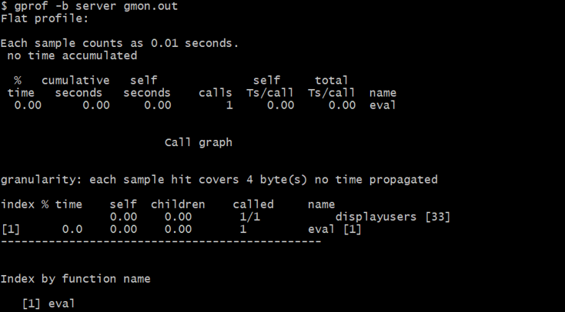

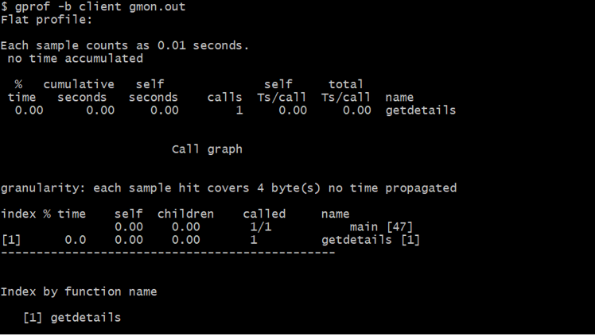

6.2 CUnit

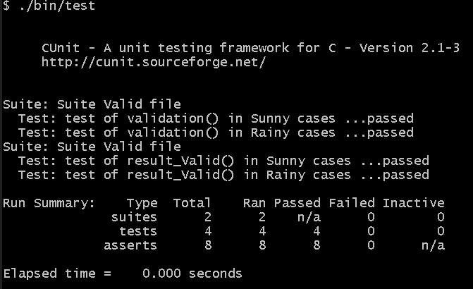

7. TESTING

7.1 Unit testing

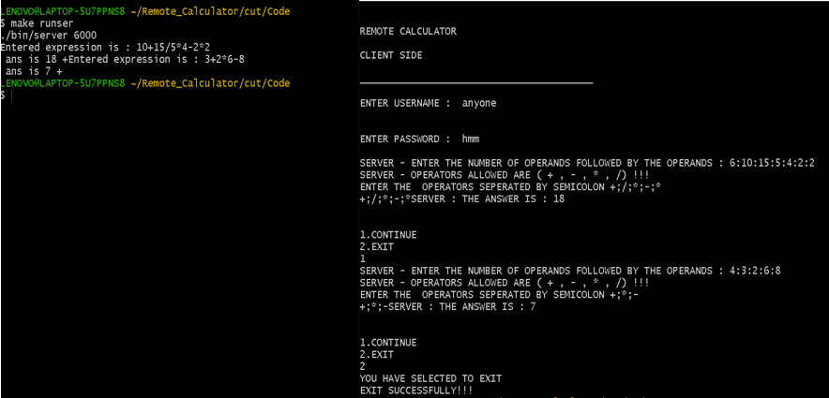

8. REQUIREMENT TRACEABILITY MATRIX(RTM)

Activity Expected Start Date Expected end date Actual Start Date Actual end date

SRS Release 13th October 18th October 13th October 19th October

Design 14th October 14th October 14th October 14th October

Coding 15th October 15th October 15th October 15th October

UT Plan 16th October 17th October 16th October 17th October

UT 16th October 17th October 16th October 17th October

IT Plan 17th October 18th October 17th October 18th October

IT 18th October 18th October 18th October 18th October

Sprint Demo 19th October 19th October 19th October 19th October